Natural Selection in Action : The Story of the Peppered Moth
Introduction
This activity is based on that well-known example of natural selection in action, the peppered moth (Biston betularia). These moths show polymorphism – the occurrence together in the same habitat and at the same time of two or more distinct forms of a species. Insect collections made during the last century contain large numbers of peppered moths. These specimens are all light-coloured in the earliest collections. Later collections show increasing numbers of dark-coloured or melanistic forms. These differences can be related to environmental changes which affected how well the two forms of moths were camouflaged and therefore how well they survived attacks by predators.
Contents
The activity consists of 10 sets of each of the following:
- Light-coloured background card
- Dark-coloured background card
- 10 light-coloured moths
- 10 dark-coloured moths
- 10 sticks + whitetac (a small piece of whitetac needs to be stuck over the end of each stick to produce a sticky ‘beak’ to pick up the moths)
Suggestions for using this resource
The following ‘mini-drama’ is just one suggestion for using the peppered moth resource. Students could be encouraged to write their own script. Teachers may wish to use different approaches with different age and ability groups.
The ‘mini-drama’ involves students working in groups of 3. There are sufficient resources for 10 groups. Each group includes a narrator, who reads out the story, a demonstrator, who uses the moths and backgrounds to illustrate the story, and a predator, who uses the sticky ‘beak’ to catch the moths.

Student Worksheet: Narrator’s script
Natural Selection in Action : The Story of the Peppered Moth
- The peppered moth is found throughout Britain. The moths are active at night and during the day they rest on tree trunks. They are eaten by birds such as thrushes, which peck them off the tree trunks.

- 200 years ago, there was very little air pollution. Tree trunks were covered with grey and white lichens (pronounced ‘likens’). Studies of insect collections from this period show that most peppered moths were speckled white. These moths were well-camouflaged against the light-coloured tree trunks and this helped to protect them from being eaten by predators.
(Demonstrator uses the resources to show camouflage)

- The light-coloured moths were able to reproduce and pass on the alleles for ‘light colour’ to their offspring. The number of light-coloured moths therefore increased because they were so well adapted to their environment.
(Demonstrator uses the resources to show reproduction)

- Occasionally, by chance, a mutation occurred during reproduction and a dark-coloured moth would be produced. However, these dark moths stood out clearly against the light tree trunks and were quickly eaten by birds.
(Demonstrator and Predator use the resources show mutation and predation)

- Then something happened to change the environment. During the first part of the nineteenth century, the Industrial Revolution caused a big increase in air pollution. Smoke from factories blackened the tree trunks and sulphur dioxide pollution killed the sensitive lichens. As a result, tree trunks in industrial areas became much darker. The light-coloured moths were no longer well-camouflaged and many more were eaten by predators.
(Demonstrator and Predator use the resources to show the change in environment and increased predation)

- Any mutant dark moths produced by chance were now at an advantage. They were well-camouflaged against the dark tree trunks and were able to survive, reproduce and pass on the alleles for ‘dark colour’ to their offspring. The number of dark-coloured moths now increased because they were better-adapted to the new environment then the light moths. This is an example of what Charles Darwin called ‘survival of the fittest’
(Demonstrator uses the resources to show reproduction)

- When a scientist called Bernard Kettlewell investigated the distribution of peppered moths in Britain in the early 1950s, he found that in industrial areas the dark form was more common and in rural areas the light form was more common.
(Demonstrator uses resources to show this distribution)

- The final twist in this story was the passing of the Clean Air Act in 1956. This resulted in a decrease in air pollution. Can you predict what effect this has had on the distribution of peppered moths and explain why this has happened? Use the resources to help you to illustrate your ideas.

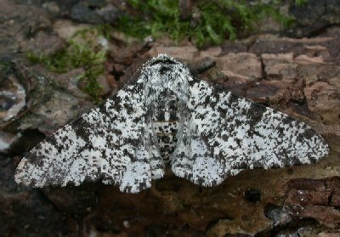
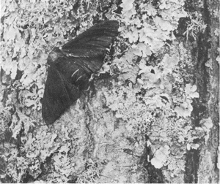
The dark form of the moth on a lichen-covered tree trunk
The light form of the moth on a dark tree trunk.

